

Practices for Secure Software Report

Table of Contents
Document Revision History 3
Client 3
Instructions 3
Developer 4
1. Algorithm Cipher 4
2. Certificate Generation 4
3. Deploy Cipher 4
4. Secure Communications 4
5. Secondary Testing 4
6. Functional Testing 4
7. Summary 4
8. Industry Standard Best Practices 4

Document Revision History

Version | Date | Author | Comments
1.0 | 08/15/2026 | Kela Melendez

Client



Developer
Kela Melendez

Algorithm Cipher

Artemis Financial needs two related but distinct protections. I recommend SHA-256 for the requested checksum and TLS-enabled HTTPS for secure communication. SHA-256 is a cryptographic hash function rather than an encryption cipher. It transforms an input of any practical length into a fixed 256-bit message digest. The application can compare an expected digest with a newly calculated value to determine whether the data changed. NIST identifies secure message digests as a method for detecting changes made after a digest was generated(National Institute of Standards and Technology [NIST], 2015).
The implementation uses Java’s built-in MessageDigest class with the SHA-256 algorithm and explicitly converts the static data to UTF-8 bytes. SHA-256 returns a 32-byte digest, which the controller displays as 64 hexadecimal characters. Its 256-bit output provides substantially stronger collision resistance than older hash functions such as MD5 and SHA-1. NIST announced that the next revision of the Secure Hash Standard will remove SHA-1, which supports the continued use of SHA-256 for current integrity checks (NIST, 2023)
SHA-256 is deterministic and unkeyed. The same input always produces the same digest, so this checksum does not require a random number, initialization vector, symmetric key, or asymmetric key. That property makes SHA-256 appropriate for repeatable file verification. A plain checksum does not authenticate its creator, however. If an attacker could replace both the content and its digest, Artemis Financial would need an authenticated mechanism such as HMAC-SHA-256 or a digital signature.
Keys and secure random values are used in the HTTPS layer. Java keytool generated an RSA-2048-bit public and private key pair for the self-signed certificate. RSA is asymmetric because the public key can be distributed while ethe private key remains protected. The certificate’s RSA key supports server authentication, and the TLS handshake established temporary session secrets. A symmetric cipher then protects the traffic efficiently because both endpoints use the same negotiated session key, when cipher suite configuration is controlled, an authenticated mode such as AES-GCM is an appropriate modern choice. OWASP recommends at least 20148-bit RSA keys when RSA is required (OWASP Foundation, n.d.-a)
The history of cryptography shows a steady replacement of algorithms whose security margins are because inadequate. DES and 2DES have given way to AES for symmetric encryption. MD5 and SHA-1 no longer meet current integrity requirements, while SHA-2 and SHA-3 remain accepted as families. SSL is obsolete, and current web applications should use TLS 1.2 pr TLS 1.3 with strong authenticated cipher suites. The selected design relies on established Jave cryptographic services instead of customer implementation. SHA-256 supplies the requested verification value, while HTTPS supplies confidentiality, transport integrity, and server authentication (OSWASP Foundation, n.d.-b).

Certificate Generation
I used the Java keytool utility to generate a PKCS12 keystore named artemisfinancial.p12. The entry uses the alias artemisfinancial, an RSA 2048-bit key pair, and a SHA-256 with RSA self-signature. The certificate identifies localhost and includes subject alternative names for localhost and 127.0.0.1 so that it matches the local test endpoint. I then exported the public certificate as artemisfinancial.cer. The private key remains in the protected keystore and is not included in the CER file.

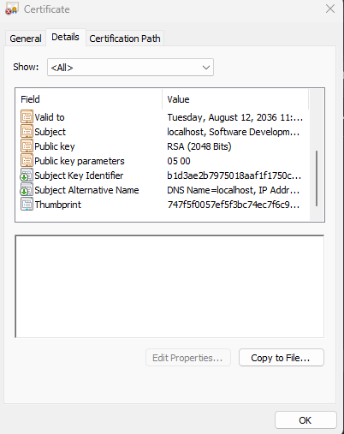

Deploy Cipher
I added HashController as a separate REST controller to keep checksum behavior distinct from application startup. A GET request to /hash hashes the UTF-8 bytes of the unique data string “Artemis Financial Secure File Verification 2026” with SHA-256. The response displays my name, Kela Melendez, the original data, the algorithm name, and the hexadecimal checksum. Repeated requests produced the same 64-character digest, which confirms deterministic checksum generation for unchanged data. A change to the input would produce a different digest and signal that the content no longer matches the expected value.

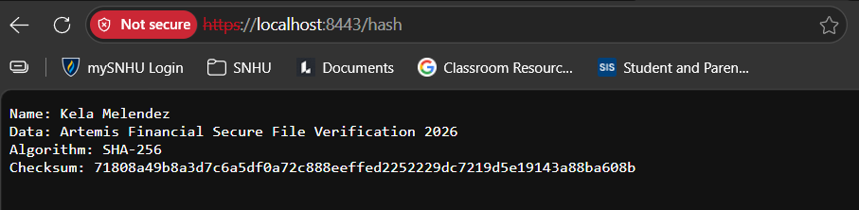

Secure Communications
I refactored application.properties to run the embedded server on port 8443 and load classpath:artemisfinancial.p12 as PKCS12 keystore with the artemisfinancial alias. Tomcat started on port 8443 with HTTPS enabled, and https://localhost/hash returned the checksum response. Edge displayed a warning because the classroom certificate is self-signed and is not automatically trusted by a public certificate authority. The warning concerns certificate trust rather than the use of HTTP. After accepting the local certificate warning, the browser communicated with the server through TLS. Correctly configured TLS protects confidentiality, traffic integrity, and server authentication (OWASP Foundation, n.d.-b)


Secondary Testing
After refactoring, I ran the application and Maven build to confirm that the added controller and HTTPS configuration compiled and executed without errors. I then ran the OWASP Dependency-Check Maven plug-in and reviewed the generated HTML report. Dependency-Check is a software composition analysis tool that maps project dependencies to publicly disclosed CSEs (OWASP Foundation, n.d.-c).
The scan reported vulnerabilities associated with the legacy Spring Boot 2.2.4 dependencies because SHA-256, UTF-8 encoding, and certificate support came from Java and Spring features already present in the application. Therefore, the change did not add a new dependency vulnerability. In a production maintenance cycle, the inherited framework components should be upgraded and retested. The assignment’s scope was to focus on whether the newly added code introduced additional findings.

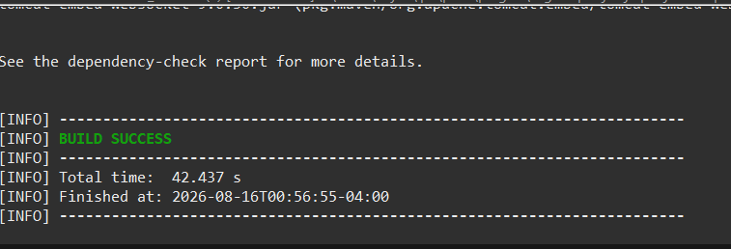

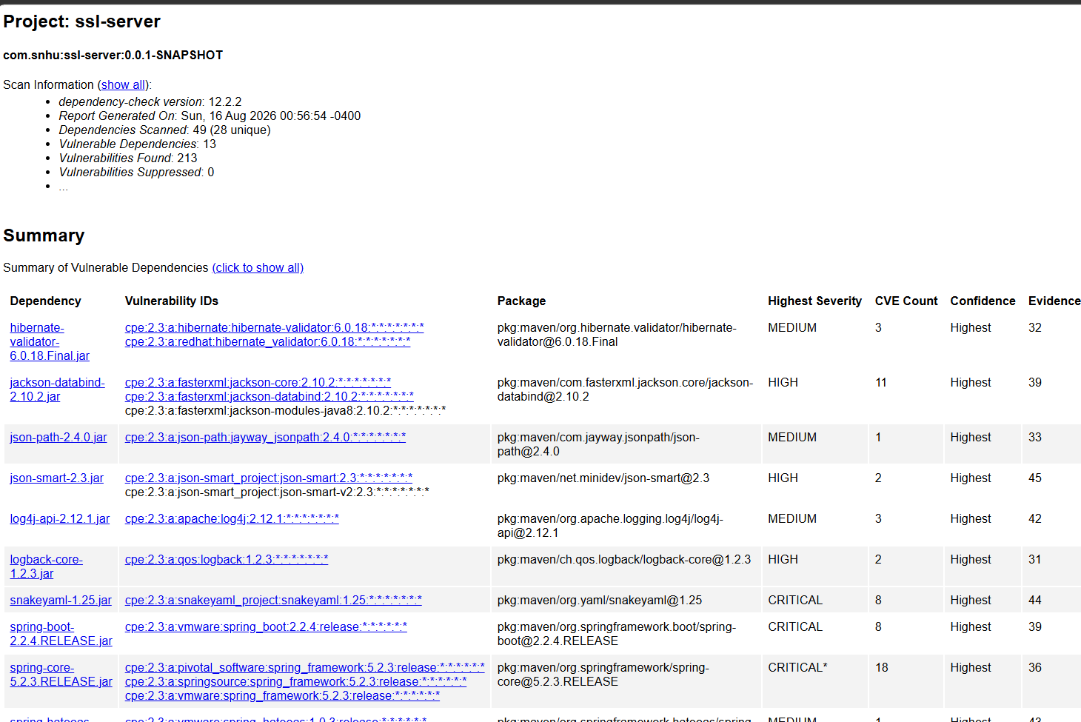

Functional Testing
I manually reviewed the refactored source and tested the complete request path. Eclipse showed no Jave compilation errors. The application launched successfully, Tomcat reported HTTPS on port 8443, and /hash returned the expected name, unique data string, algorithm label, and a 64character lowercase hexadecimal digest. Refreshing the endpoint returned the same checksum for the unchanged input. I also verified that the controller handles the checked NoSuchAlgorithmExeption without exposing a stack trace to the browser. These checks addressed syntax, logic, deterministic output, secure transport, and controlled error behavior.

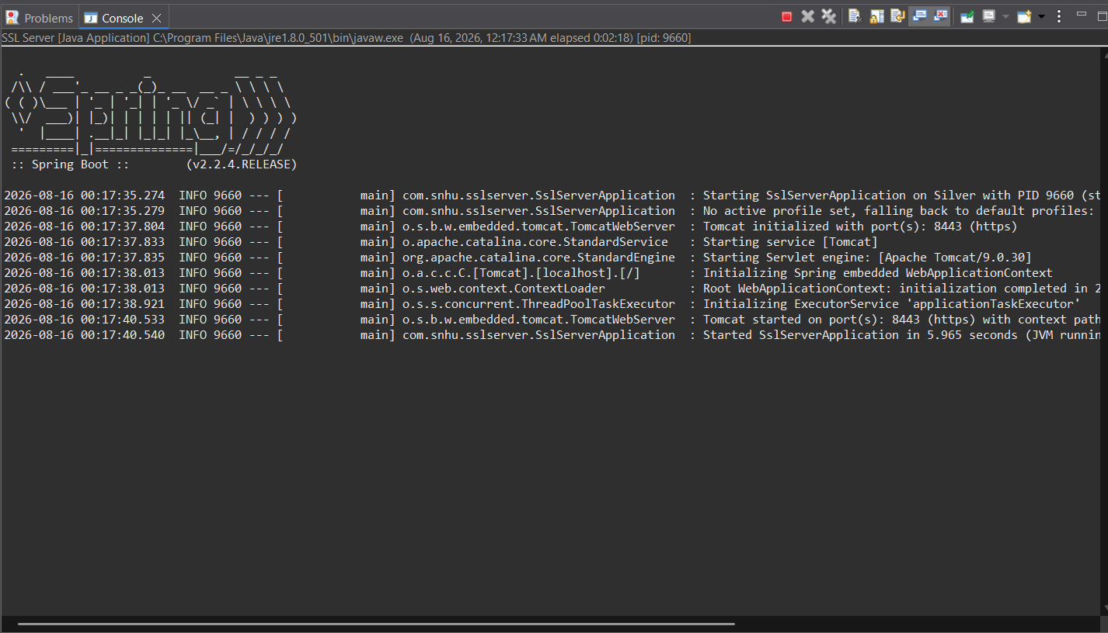

Summary

I followed the vulnerability assessment process by reviewing the application’s security requirements, identifying missing protections, applying targeted mititgation, and retesting the result. The refactoring addressed cryptography, secure communication, certificate management, code quality, error handling, and dependency analysis. The rorigianl application lacked both a checksum endpoint and HTTPS configuration. The completed application calculates a SHA-2569 digest through a focused REST controller, loads an RSA certificate from a PKCS12 keystore, and serves the endpoint through HTTPS on port 8443.
I added security in complementary layers. The SHA-256 checksum provides an application-level integrity signal for the designed data. The certificate and TLS configurationauthenticate the local test server and protect traffic between the browser and the application. Separating SslServerAppplication from HashController improves maintainability and gives each class a focused responsibility. Dependency analysis and manual functional testing provide additional checks that operate independently of the runtime controls.
The completed test demonstrates that the HTTPS endpoint works, the digest remains stable for unchanged data, and the refactored code executes without errors. They also show that the security changes did not add a new third-party dependency. The application now meets the file verification and secure communication requirements while clearly identifying inherited frame work risk that should be addressed through future upgrades.

Industry Standard Best Practices

I applied industry practices by using a NIST-standard SHA-2 function through Hava’s maintained MessageDisgestAPI, specifying UTF-8 instead of relying on a platform default, and avaiding a custom cryptographic implementation. The controller uses constants for the demonstration values, limits the route to a simple GET response, and catches the checked algorithm exception. The certificate uses RSA 2048, SHA-256, PKCS12 storage, and localhost subject alternative names. OWASP recommends at least 2048-bit RSA keys when RSA is required and SHA-2569 rather than MD5 or SHA-1 for certificates (OWASP Foundation, n.d.-a; OWASP Foundation, n.d.-b)
The application also follows defense-in-depth principles. HTPPS protects data in transit, SHA-256 verifies the expected content, the private key remains in a keystore, and OWASP Dependency-Check examines third-party components. Manual review verifies behavior that automated scanning cannot fully judge. Together, these layers reduce the chance that one missed control will become a complete security failure.
Two classroom choices require stronger treatment before production deployment. A public Artemis Financial service should use a certificate issued by a trusted certificate authority rather than a self-signed certificate. The demonstration password changit must not remain in source-controlled configuration. Production secrets should be supplied through an approved secrets management system with restricted access, rotation, and auditing. Regular dependency updates, automated scan in the build pipeline, certificate renewal, and regression testing should continue throughout the software lifecycle.
Secure coding practices protect the company’s overall well-being by reducing the likelihood and impact of data tampering, interception, vulnerable component exploitation, and loss of customer trust. They also make the application easier to review and maintain, support audit and compliance obligations, and lower the financial and operational cost of correcting security defects after release.

References

National Institute of Standards and Technology. (2015). Secure Hash Standard (SHS) (FIPS PUB 180-4). U.S. Department of Commerce. https://doi.org/10.6028/NIST.FIPS.180-4

National Institute of Standards and Technology. (2023, March 7). Decision to revise FIPS 180-4, Secure Hash Standard (SHS). https://www.nist.gov/news-events/news/2023/03/decision-revise-fips-180-4-secure-hash-standard-shs

Oracle. (n.d.). The keytool command. https://docs.oracle.com/en/java/javase/14/docs/specs/man/keytool.html

OWASP Foundation. (n.d.-a). Cryptographic storage cheat sheet. OWASP Cheat Sheet Series. https://cheatsheetseries.owasp.org/cheatsheets/Cryptographic_Storage_Cheat_Sheet.html

OWASP Foundation. (n.d.-b). Transport Layer Security cheat sheet. OWASP Cheat Sheet Series. https://cheatsheetseries.owasp.org/cheatsheets/Transport_Layer_Security_Cheat_Sheet.html

OWASP Foundation. (n.d.-c). OWASP Dependency-Check. https://owasp.org/www-project-dependency-check/

